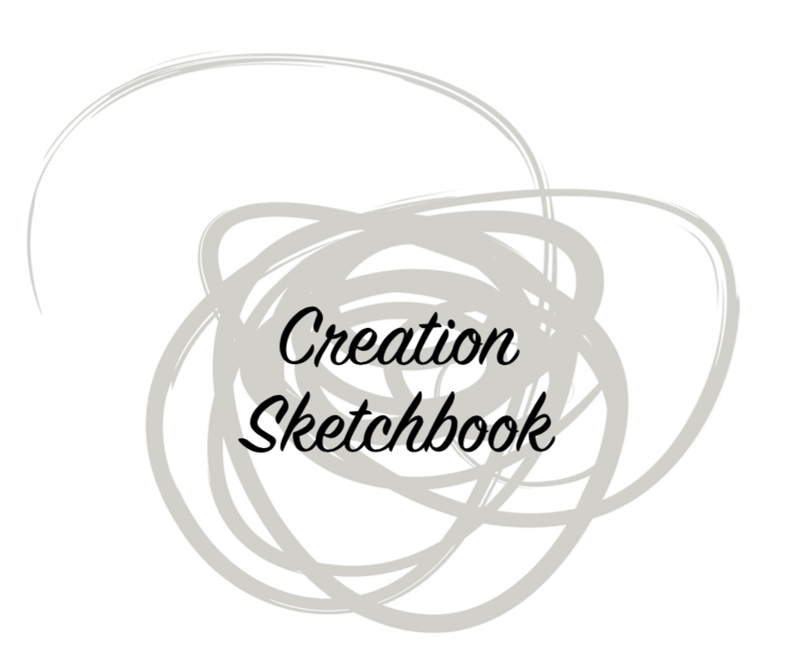

An art retreat by Christopher Alt, SJ

Name:________________________________

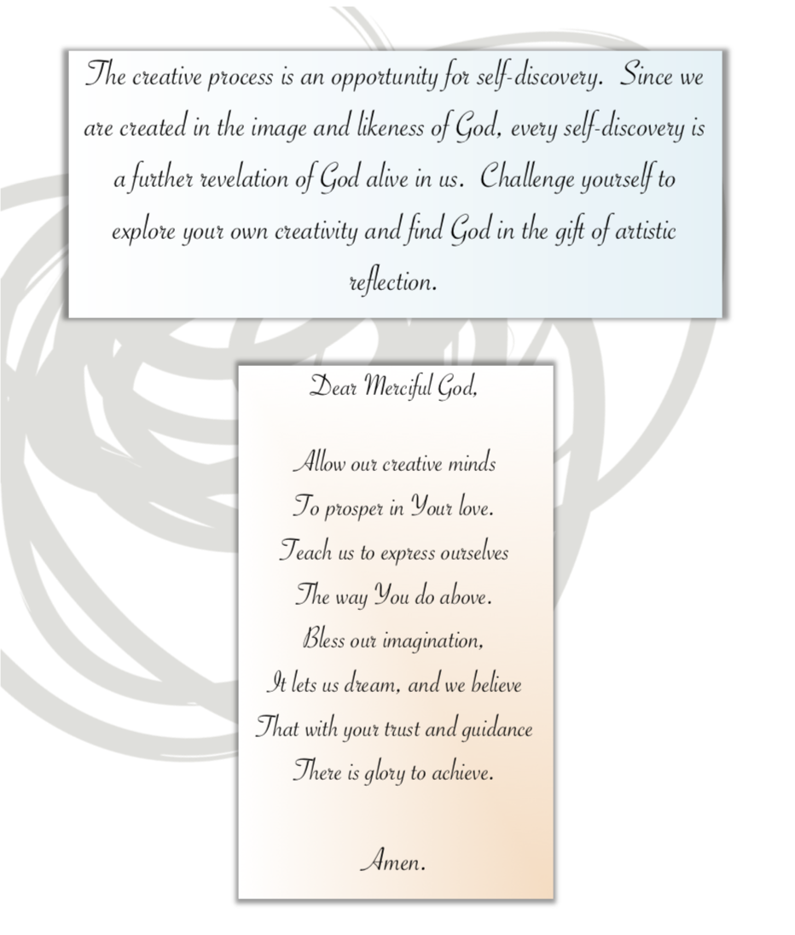
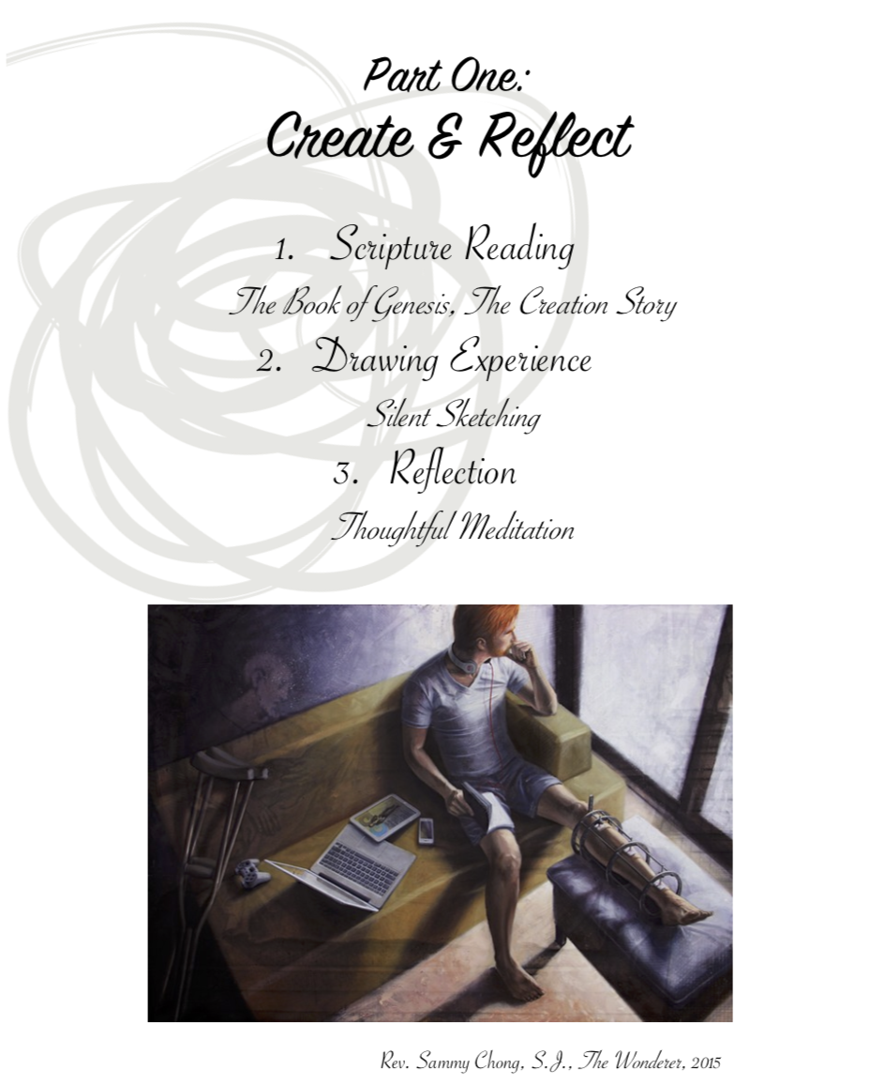

What we are living now is a place of 'metanoia' (conversion), and we have the chance to begin…So, let's not let it slip from us, and let's move ahead….I’m living this as a time of great uncertainty. It’s a time for inventing, for creativity.

– Pope Francis, April 2020

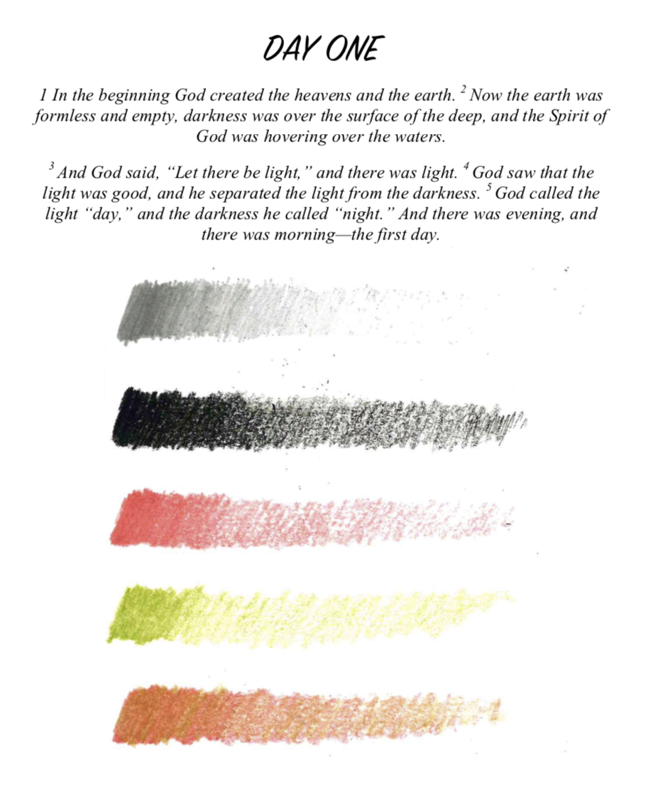

Reflection Questions for DAY ONE
- What are the most important ‘beginning’ moments in your spiritual life?
- How and in what ways does the light of faith help you see things differently?
- In what ways do you resist the light of faith? What is behind this resistance?

SKETCH ONE

Element of Design: Value

Materials: Pencil, Charcoal Pencil, Pastel Pencil

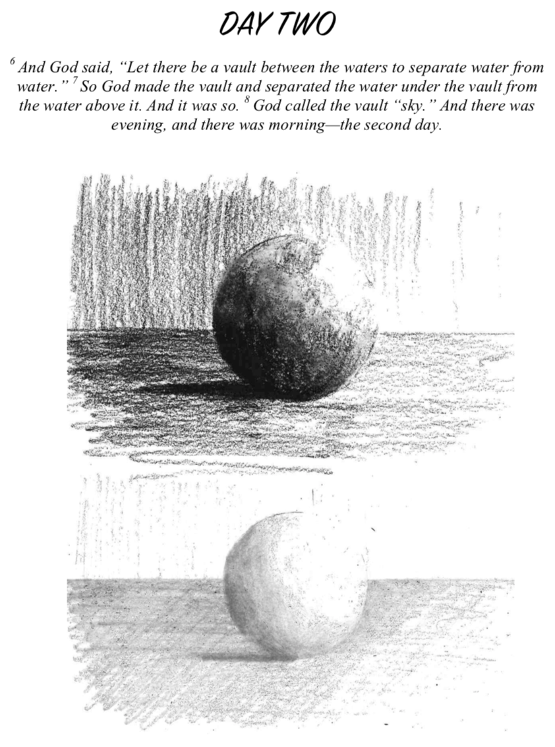

Reflection Questions for DAY TWO
- How comfortable are you with the “slow work of God”?
- What in your life remains blurry, that you’d like more clarity on and courage with?
- What are the most important “everyday sacraments” of your life?
SKETCH TWO

Element of Design: Form

Materials: Pencil, Charcoal Pencil

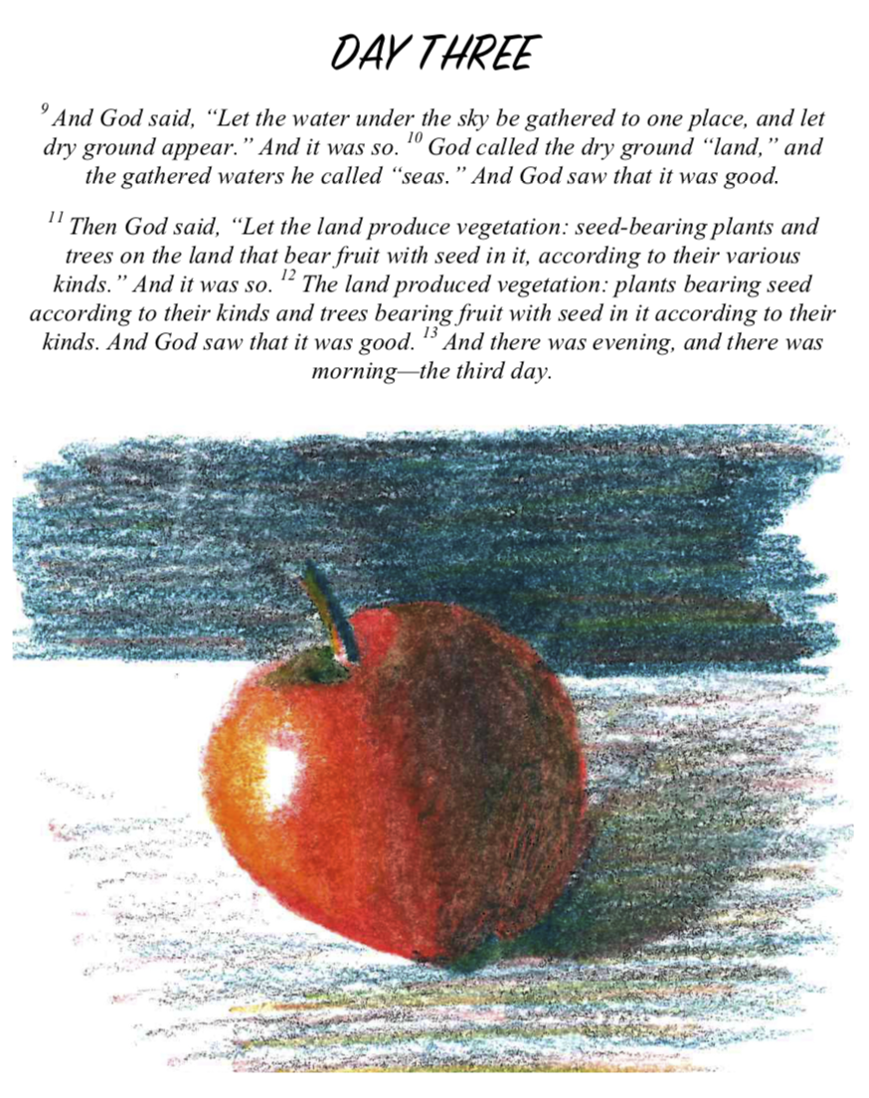

Reflection Questions for DAY THREE
- If your spirituality had a color and shape, what would it look like and why?
- In what ways can you be more generous?
SKETCH THREE

Element of Design: Color

Materials: Pastel or Colored Pencil

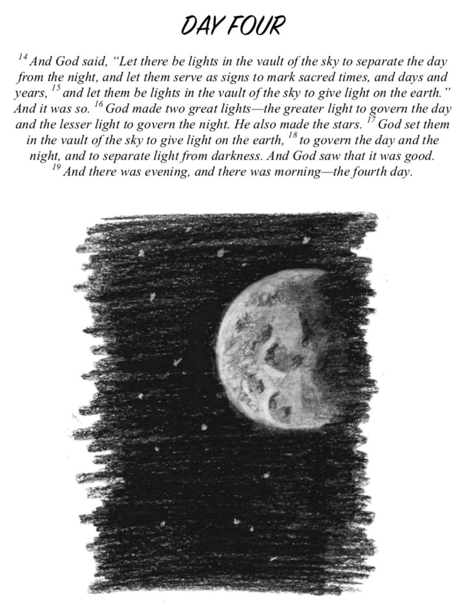

Reflection Questions for DAY FOUR
- What is your favorite time and place to pray? What rhythm and movements of the liturgy do you find most life-giving? Why might this be?
- Recall a time you felt close to Jesus? Take some time to savor the memory of that experience.
- At this time, how is God inviting you to see more clearly, follow more nearly, and love more dearly?
SKETCH FOUR

Element of Design: Space

Materials: Black Charcoal Pencil & White Charcoal Pencil

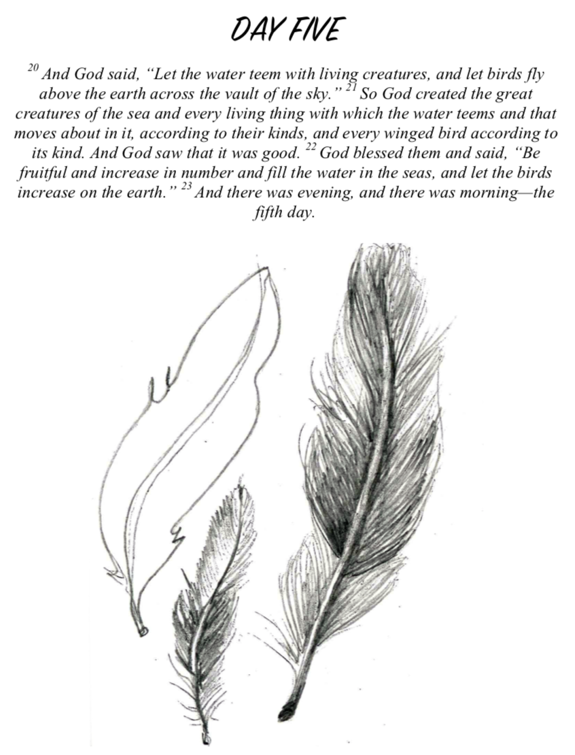

Reflection Questions for DAY FIVE
- What are some everyday sights, sounds, smells, tastes, and touches that bring you joy? How might they be the Spirit’s way of leading you to God?
- What personal practices of gratitude have you created and do regularly? Do you need to make create some?
SKETCH FIVE

Element of Design: Texture

Materials: Your Choice

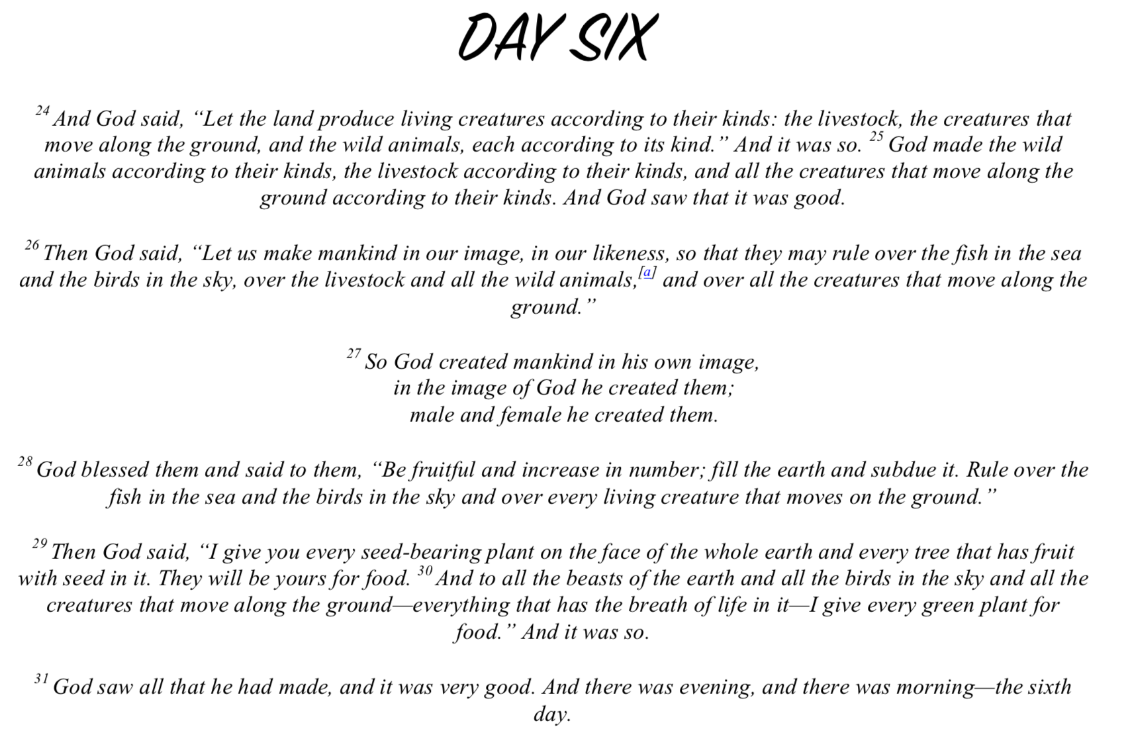

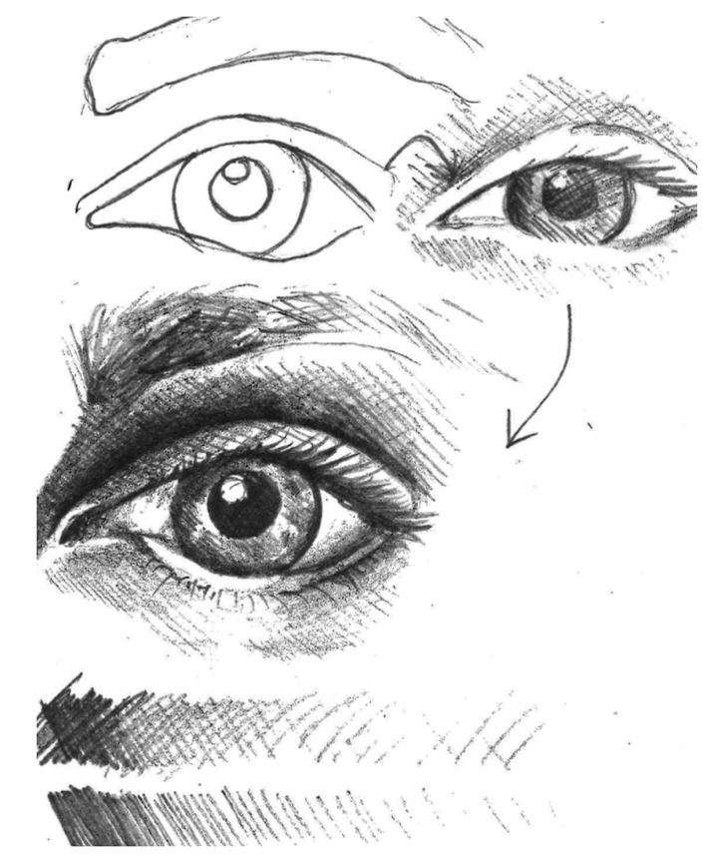

Reflection Questions for DAY SIX
- Who are the people in your life that have had the greatest impact on your spiritual life?
- When you imagine God looking at you, what do you see?
- What does it feel like to see God looking at you in love? How might you better live out of this love and let it influence the way you serve others?
SKETCH SIX

Element of Design: Line

Materials: Pencil

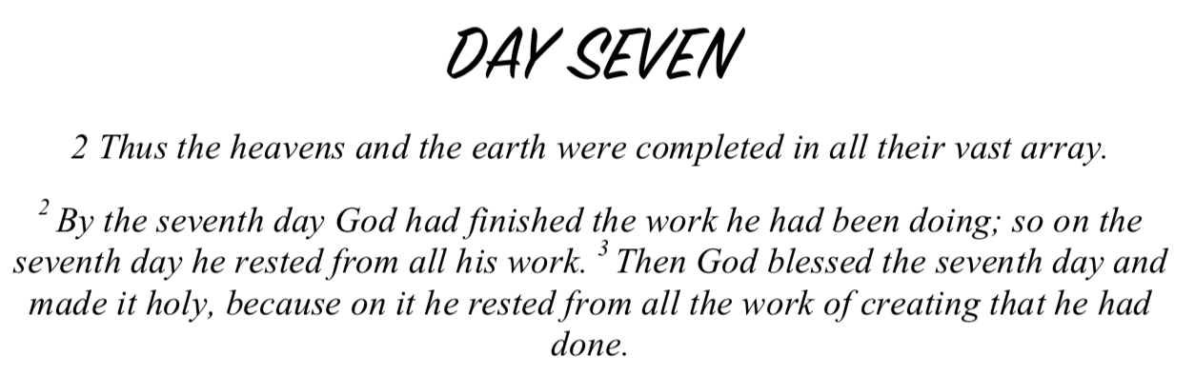

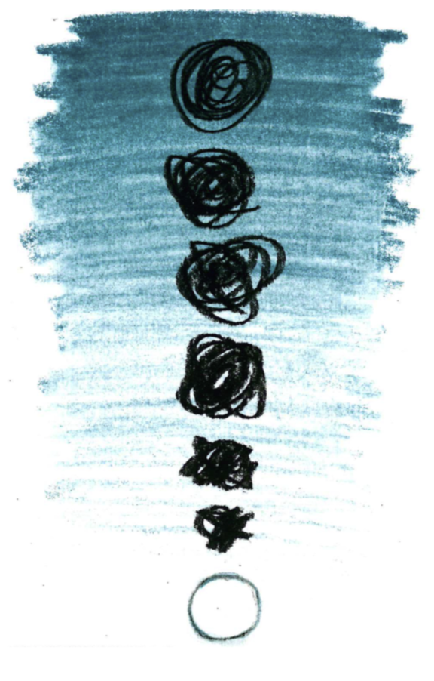

Reflection Questions for DAY SEVEN
- Imagine your perfect day with God. What does it look like? What are you doing? Engage all your senses. Be aware of your thoughts and feelings.
- Do you have a ‘small’ or ‘big’ God? Does your image of God need to change and grow? How comfortable are you loving the incomprehensibility of God?
- Do you embrace the mystery of who you and others are?
- In what ways can you better acknowledge, accept, reverence, celebrate, and serve the mystery of creation?
SKETCH SEVEN

Element of Design: Shape

Materials: Your Choice

